Lab Objective

Learn how to Configure a domain user password policy

**Lab Procedures**

# Installing Windows Server Backup

**1.** Log in to RWDC01 as the **Contoso\Administrator** user account. The Server Manager console opens.

**2.** On Server Manager, click Tools >Group Policy Management. The Group Policy Management console opens.

**3.** Find and right-click Default Domain Policy and click Edit. The Group Policy Management Editor opens.

**4.** In the left window pane, expand the Computer Configuration node, expand the Policies node, and expand the Windows Settings folder. Then, expand the Security Settings node. In the Security Settings node, expand Account Policies and select Password Policy, as shown in Figure 18-1.

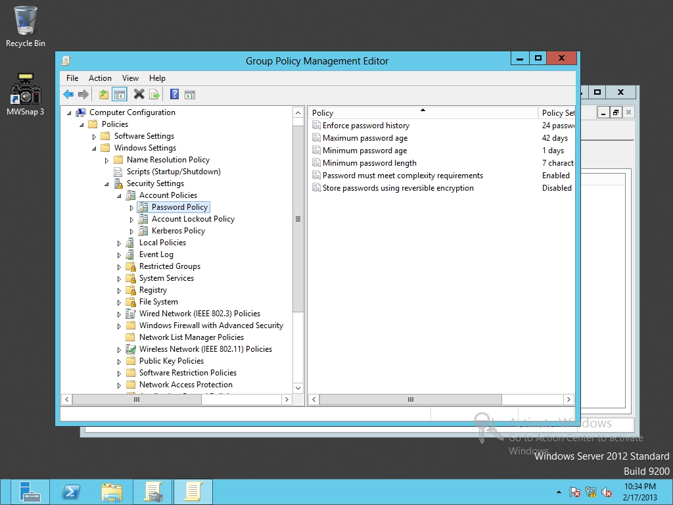

Figure 18-1

Managing Password Policy

**5.** Double-click the Minimum password length. When the Minimum password length Properties dialog box opens, change the 7 value to 8 characters. Click OK to close the Minimum password length Properties dialog box.

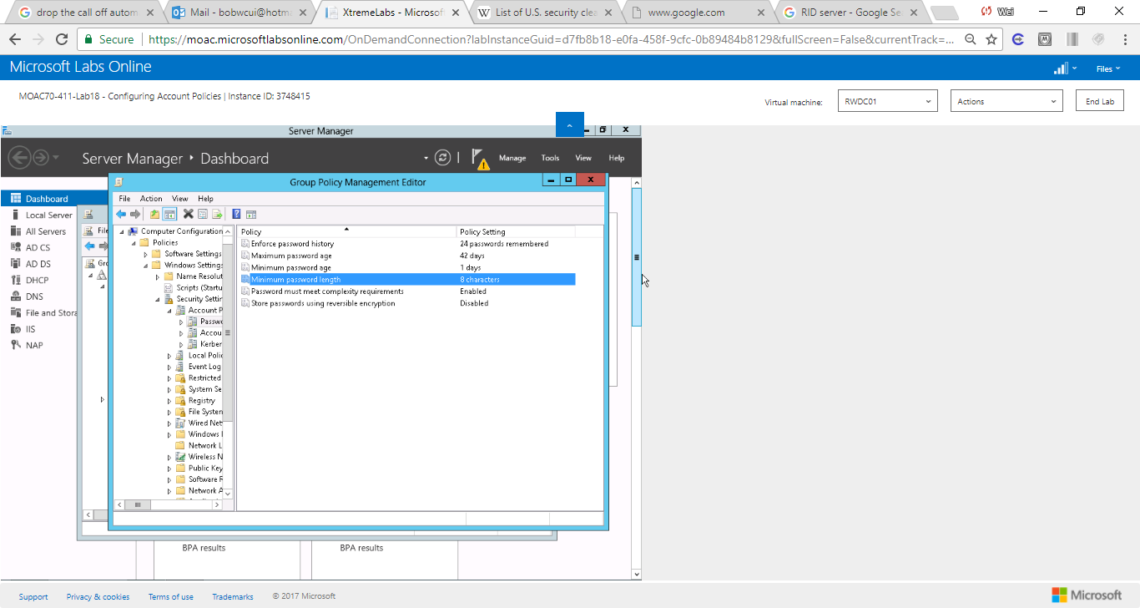

Figure 1 Changed the minimum length from 7 to 8.

**6.** Keep the Default Domain Policy Group Policy Management Editor window open for the next exercise.

End of exercise.

**Lab Summary**

In this exercise, I defined a domain-level password policy including maximum password length and password history. Password policy can determine settings for passwords, such as enforcement, lifetimes, length, and complexity requirements. It is the first line for cyber security.